First Create a repo using github interface.  
Then add a ReadMe.md file   
then add a remote and push origin using command form github.  
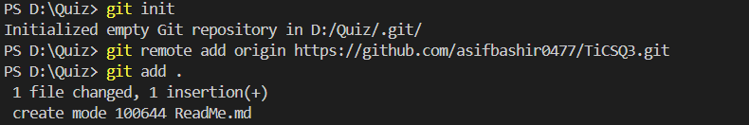  
  
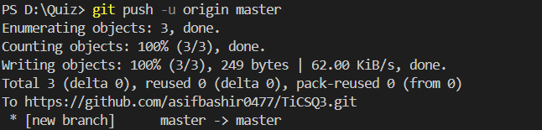  
Then create a python file:  
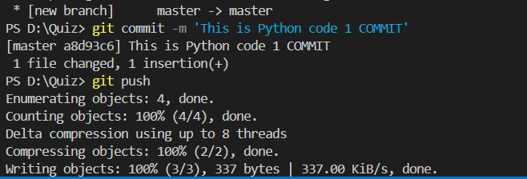  
Then Create a C sharp file:  
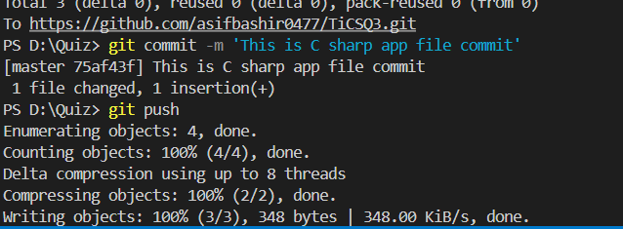  
tHEN CREATE A jaVA fILE:  
